List of experiments

- To determine the uniaxial compressive strength of a given rockspecimen

- To determine the tensile strength of a given rockspecimen.

- To determine the shear strength of given rock specimen by Single shearmethod

- To determine the shear strength of given rock specimen by Double shearmethod.

- To determine the Point Load Strength Index of a given rock specimen and to calculate uniaxial compressive strength.
- To determine the Protodyakonov strength index of coal.
- To determine the Impact Strength Index (ISI) ofcoal.

- To determine the Schmidt Rebound Hammer Number and compressive strength of given rock specimen.
- To determine the Slake Durability Index of given rock specimen.

- To determine the P & S wave velocity and the dynamic properties of a given rock specimen.

EXPERIMENT No. 1

AIM: To determine the uniaxial compressive strength of a given rock specimen and to calculate the Young’s Modulus.
Scope: The procedure used in the determination of compressive strength involves the use of a cylindrical specimen of rock loaded axially between platens in a testing machine. The stress value at failure is defined as the compressive strength of the specimen and is given by the relationship-
(UCS) σ_{c} = P / A
Where, σ_{c} = compressive strength of the specimen P = applied load at failure (Kg.)
A = cross-sectional area (sq.cm.)

Specimen Specification:
- Specimen is straight, circular cylinder having a length to diameter ratio of 2.5-3.0 and diameter preferably not less than NX Core size (i.e. approx. 54 mm). The diameter of specimen is related to the size of the largest grain in rock by the ratio of at least10:1.
- The ends of the specimen are cut parallel to each other and at right angle to the longitudinal axis.
- The ends of the specimen are flat to 0.02mm.
- The ends of the specimen are perpendicular to the axis of the specimen within 0.001 radian or 0.05 mm in 50mm.
- Thesidesofthespecimenaresmoothandfreeofabruptirregularitiesandstraighttowithin
0.3 mm over the full length of the specimen.
- Samples are stored for no longer than 30 days in such a way as to preserve the natural water content as far as possible until the time of specimen preparation. The specimen is storedprior totestingfor5to6daysinanenvironmentof20⁰C+2⁰Cand50%5%humidity.
Apparatus Required: MTS, Vernier Caliper and rock specimen.

Procedure
- Measure the length of the specimen at two places at right angle to each other and diameter of the specimen to the nearest 0.1 mm by averaging two diameters measured at right angles to each other at about the upper height, mid height, and the lower height of the specimen. Use average diameter for calculating the cross-sectionalarea.
- Load the specimen under Servo Controlled Stiff Testing Machine (MTS) in such a way that the stress rate is within the limits of 0.5-1.0MPa/sec.
- Obtain the stress strain curve or load vs displacement curve from theMTS.
- Select a straight line of the curve in the elastic limit and calculate stress and strain from load versus displacement curve. Divide stress by strain to get young’s modulus of thespecimen.

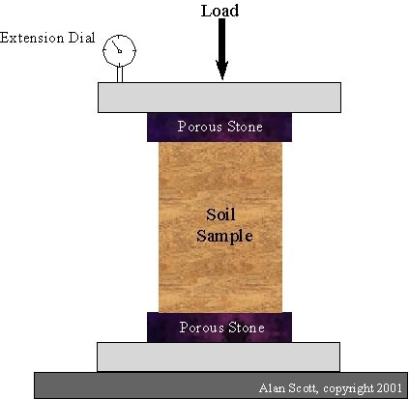

Calculation:
It is calculated by dividing the maximum load at failure by cross-sectional area of the specimen. σ_{c} = P / A

Where, P is load at failure (Kg.)
A is cross-sectional area (sq.cm.)

Observation Table :

S.  No  . | Length of the Specimen (cm.) |  |  | Diameter of the Specimen (cm.) |  |  |  |  |  |  | Cross-sectional Area (sq.cm.) A | Load at  Failure (kg.)P | σ_{c} =  P / A  (MPa)
 | L₁ | L₂ | Lav | D₁ | D₂ | D₃ | D₄ | D₅ | D₆ | Dav
1
2
3
4
5
Average
Result:

  - No. of specimentested
  - Uniaxial CompressiveStrength
  - Mode offailure
  - Lithological description of the rock specimen
  - Source of sample : ChunarSandstone
  - Date of testing
  - Type of testingmachine
  - Water content & degree of saturation at the time oftest

FIGURES OF FRACTURED SPECIMEN UNDER COMPRESSION

EXPERIMENT NO. 2

Aim: To determine the tensile strength of a given rock specimen.
Scope : The specimen tested for compressive strength often fails due to the development of tensile stresses. Tensile failure is an important phenomenon in the mechanical winning of minerals, drilling and blasting of rocks, failure of roof and floor etc., particularly because rocks are very much weaker in tension than in compression.
There are two methods to determine the tensile strength-
    - DirectMethod. 2. IndirectMethod.
The greatest difficulty in the direct test for determination of tensile strength of rocks is the gripping of specimen. To get uniform tensile stress distribution and for easy gripping, specially prepared specimens are required and they are difficult to make. As a result, indirect methods have been developed for determining the tensile strength of rocks.
Brazilian Test : The Brazilian Test, as the name suggests, originated from South America. The test makes use of a circular solid disc which is compressed to failure across a diameter. However, the test is valid only when the failure of disc initiates with a vertical crack originating from the centre of the disc and proceeding upward and downward along the loadingdiameter.

Apparatus Required
- Brazilian cage - Two steel loading jaws designed so as to contact a disc shaped rock specimen at diametrically opposed surfaces over an area of contact of approximately 10⁰ at failure. The critical dimension of apparatus is the radius of curvature of jaws and length of guide pins coupling the two curved jaws and the width of the jaws. The radius of jaws is 1.5 x specimen radius, guide pin permit rotation of one jaw relative to the other by 4 x 10⁻³radiansoutofplaneoftheapparatus(25mmpenetrationofguidepin).Widthofthejawis
  - x specimen thickness. The upper jaw contains a spherical seating formed by a 25 mm diameter half ball bearing.
- A suitable machine for applying and measuring compressive load to thespecimen.
- VernierCaliper.
- RockSpecimen.

Procedure
- Take the cylindrical specimen whose surfaces are free from any tool marks and irregularities. The end faces are flat to within 0.25 mm and parallel to within0.25⁰.
- The specimen diameter is not less than NX (apparatus 54 mm) core size. Thickness of specimen is equal to specimen radius.
- Apply the load on the specimen continuously at a constant rate such that failure in the weakest rock occurs within 15-30 sec. A loading rate of 200 N/s isrecommended.
Calculation : The Brazilian tensile strength which is defined as the load resisting ability of rock under diametral loading, can be calculated by the expression -
σ_{t} ={2 P / ( π D t )} or {P / ( π r t )}
where, σ_{t} = tensile strength, (MPa) P = load at failure,(N)
D = diameter of specimen, (mm) t = thickness of specimen, (mm) r = radius of specimen,(mm)

Observation Table :

S.N  . | Diameter (D, mm) |  |  | Thickness (t, mm) |  |  | Load at Failure (Kg, P) | Tensile Strength (MPa)
 | D₁ | D₂ | Dav | t₁ | t₂ | tav
1
2
3
4
5
 |  |  |  |  |  |  | Average
Result:

- Lithological description of the specimen:

- Source of sample:
- Number of specimen:
- Specimen diameter and thickness:
- Water content and degree of saturation at the time of test:
- Test duration:
- Date of testing and type of testing machine:
- Tensile strength of the rock specimen :

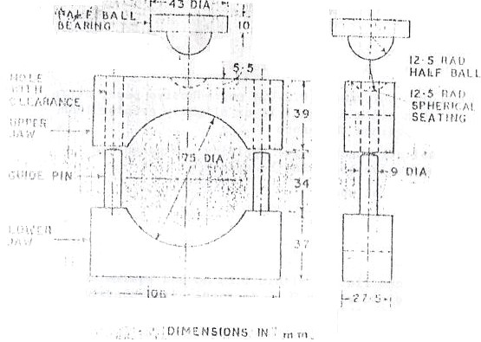

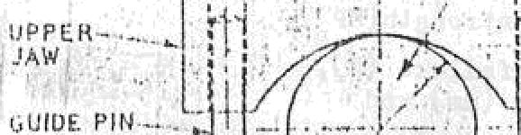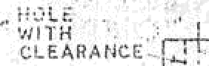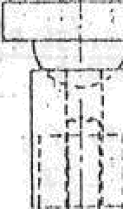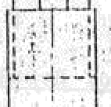
,' ii yrt
SP tCI MIN.
,C.R.0CKDISC3

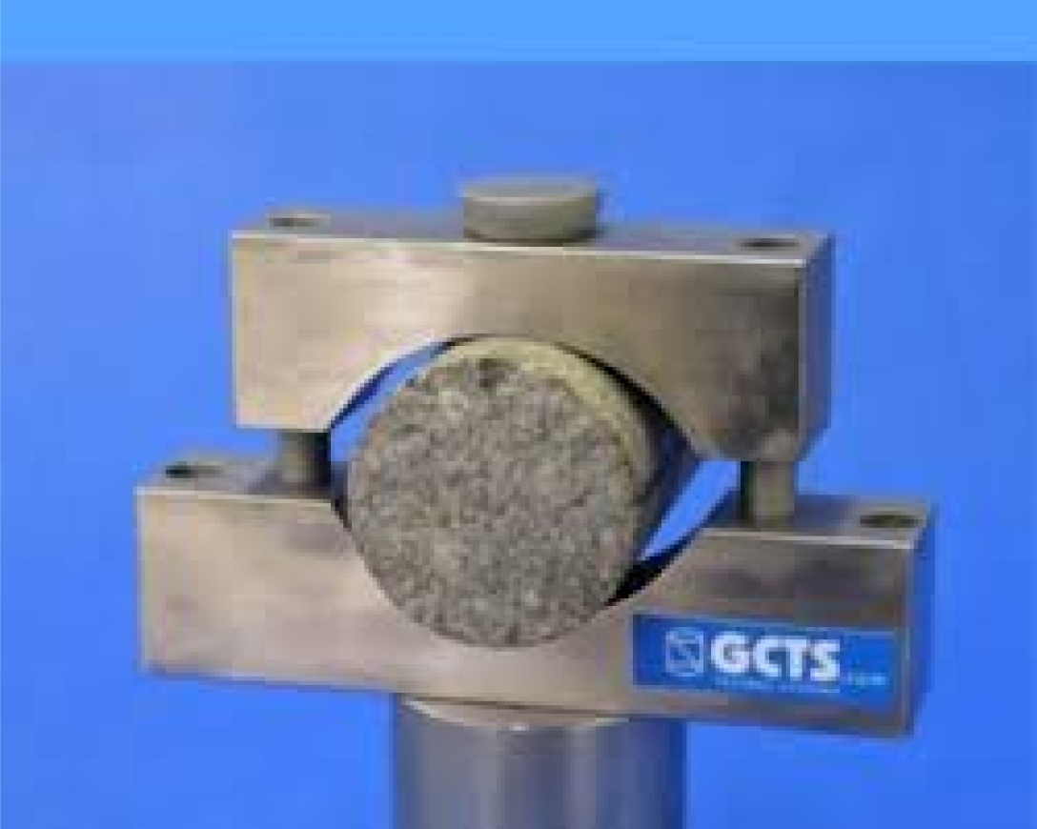

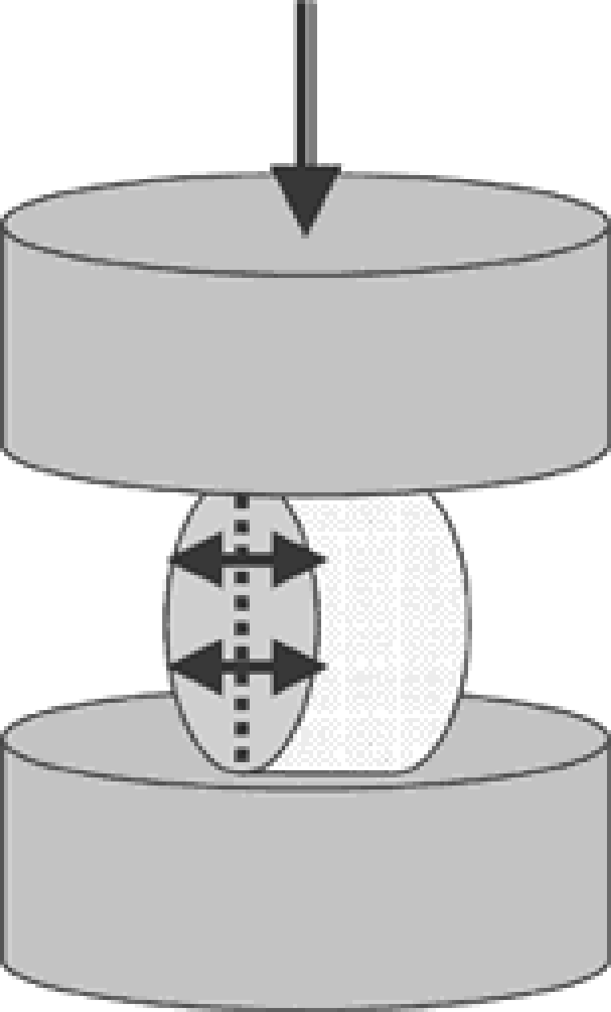
Load

EXPERIMENT NO. 3

Aim: To determine the shear strength of given rock specimen by . Double shear method
Shear Strength : It is defined as the breaking shear stress applied to an imposed plane with normal force lacking (Everling, 1964). In other words, a state of pure shear is said to exist if planes of maximum shear stress are free of any normal stress (Obert and Duval, 1967). There are several methods for the determination of shear strength. They may be classified into two broad groups-
  - Unconfined methods
  - Confined methods.
The unconfined and confined methods can be further classified as –

UnconfinedMethods
  - Single Shear (by bending)
  - Double Shear
  - PunchShear
  - Torsion Shear
  - Single Shear (by inclineddies)
  - Indirect

ConfinedMethods
  - Biaxial
  - Triaxial
Apparatus Required: Single Shear cage, Double shear cage, UTM, rock specimens, Vernier caliper.

Double shear :
- Take specimen of NX size diameter (apprx. 54 mm) and length 7.5 cm. It is placed in the double shear box centrally, such that no edge remains outside the hole of box. The specimen fitted in double shear cage is kept under the loadingmachine.

- Apply the load continuously in such a way that shear displacement is less than 0.1mm/min.
- Record the failure load from the loading machine i.e. UTM. and time span offracture.
- Calculate the double shear strength of the specimen by the formulae givenbelow- Double ShearStrength (σ_{s}) = P/2A
Where, P = load at failure, Kg
A = Cross-sectional area, cm²

Observation Table:
Double Shear Strength

S.N  . | Length of Specimen  (cm) |  |  | Diameter of Specimen  (cm) |  |  | Cross- sectional area  (A, cm²) | Failure Load  (P, kg) | Shear strength  (MPa)
 | L₁ | L₂ | Lav | D₁ | D₂ | Dav
1
2
3
4
5
Average

Results
- Lithological description of the specimen:
- Source of the sample :
- No. of specimen tested by :
Single shear method :
Double shear method :
- Specimen diameter andLength Single shear method :
Double shear method :.
- Water contained and degree of saturation at the time of test:
- Testduration
Single shear method :
Double shear method :
- Date of testing and type of testing machine:
- Single shear strength of rock
Double shear strength of rock:

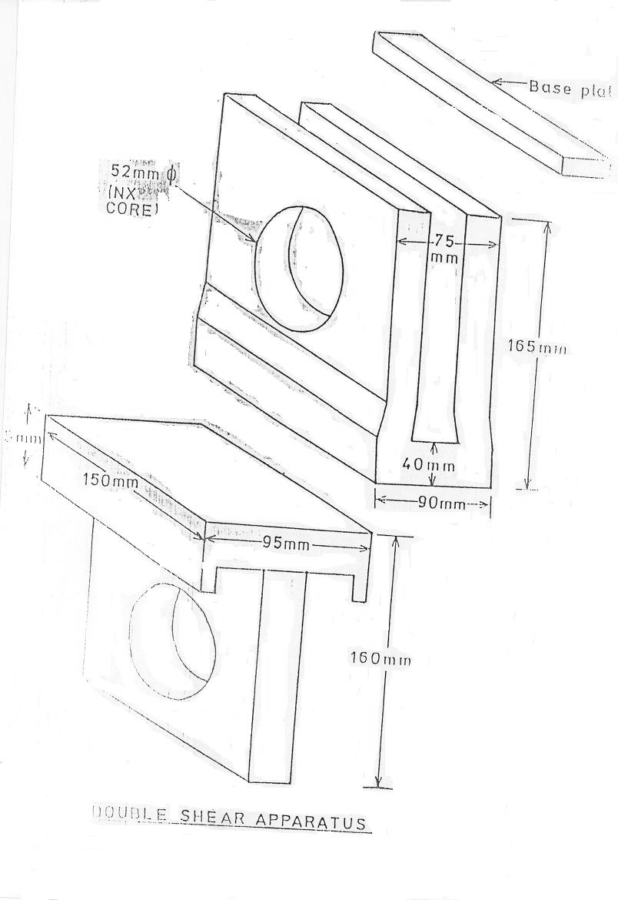

EXPERIMENT NO. 4

Aim: To determine the shear strength of given rockspecimen by Single shear method

Shear Strength : It is defined as the breaking shear stress applied to an imposed plane with normal force lacking (Everling, 1964). In other words, a state of pure shear is said to exist if planes of maximum shear stress are free of any normal stress (Obert and Duval, 1967). There are several methods for the determination of shear strength. They may be classified into two broad groups-
  - Unconfined methods
  - Confined methods.
The unconfined and confined methods can be further classified as –

UnconfinedMethods
- Single Shear (by bending)
- Double Shear
- PunchShear
- Torsion Shear
- Single Shear (by inclineddies)
- Indirect

ConfinedMethods
- Biaxial
- Triaxial
Apparatus Required: Single Shear cage, Double shear cage, UTM, rock specimens, Vernier caliper.

Procedure :
Single Shear:
- Take the specimen of 2.5 cm diameter and 6 cm length and encapsulate in a manner that the normal force should act normal to the shearing plane passing through itscentre.
- Place the specimen in the shear box and keep under the loadingmachine.
- Apply the load continuously in such a way that shear displacement should be less than 0.1 mm/min.
- Record the failure load from the loading machine i.e.UTM.
- Also record the time span offacture.
- Now the shear strength at a particular inclined plane can be calculated by theformulae

PCosα A
Single Shear strength (σ_{s}) =
where, P = load at failure, Kg A = L x D, cm²
α = angle of fracture to compression axis, degree
L = length of specimen, cm D = diameter of specimen, cm
- Also calculate the normal stress at that particular inclined plane by theformulae-

PSin α A

σ_{n} =
where, P = load at failure, Kg A = L x D, cm²
α = angle of fracture to compression axis, degree
L = length of specimen, cm D = diameter of specimen, cm

- Calculate the shear stress and normal stress at differentangles.
- Plot the normal stress versus shear stress on a graph paper. Take normal stress on x – axis and shear stress on y – axis. Obtain the shear stress value at zero normal stress. That is the shear strength of the specimen.

Observation Table :
(1) Single Shear

S.  N. | Length of  Specimen (cm) |  |  | Diameter of Specimen(cm) |  |  | Area (A,cm²) | Failure Load (kg, P) | Angl e  (α) | Shear Stress (Kg/cm²) | Normal stress (Kg/cm²)
 | L₁ | L₂ | Lav | D₁ | D₂ | Dav
1
2
3
4
5

Results
- Lithological description of the specimen:
- Source of the sample :
- No. of specimen tested by :
Single shear method :
Double shear method :
- Specimen diameter andLength Single shear method :
Double shear method :.
- Water contained and degree of saturation at the time of test:
- Testduration
Single shear method :
Double shear method :
- Date of testing and type of testing machine:
- Single shear strength of rock : Double shear strength of rock:

EXPERIMENT No. 5

Aim: To determine the Point Load Strength Index of a given rock specimen and to calculate uniaxial compressive strength.
Theory: Point load index is a simple technique for measuring the strength of rock specimen in the field by using portable equipment. The specimens may be rock core or irregular lumps. The strength index is calculated from the following equation
I_{s} = P/D²

where,

I_{s} = point load strength index P = load at fracture
D = Distance between two conical platens

Approximate conversion of Point Load Strength Index to Uniaxial Compressive Strength can be made by
U.C.S. = (24) I_{s}
It varies from 12 to 24 depending upon the nature/type of specimen.

The International Society of Rock Mechanics has given three methods for determining the point load strength index
  - DiametralTest
  - Axialtest
  - Irregular lump test.
Apparatus Required: Point load machine, distance measuring system to indicate the distance between two conical platens, specimen, Vernier Calipers.
.

Procedure:
- Diametral Test: Take Core specimens with length to diameter ratio greater than 1.4 for diametral testing. Insert the specimen in the testing machine and bring the platens into the contact along the core diameter, ensuring that the distance L between the contact point and the nearest free end is at least 0.7d, where d is core diameter. Increase the load till the specimen breaks. Now, record the distance between conical platens (D) and failure load P. Repeat the procedure on at least ten specimens for eachsample.
- Axial Test: Take core specimens with length to diameter ratio of 1.1 ± 0.05 for axial test. Insert the specimen in the testing machine and bring the platens into the contact along the axis if the specimen (i.e. length of the specimen). Now, load the specimen to failure and record the distance between conical platens (D) and failure load P. Repeat the procedure on at least ten specimens for each sample.
- Irregular Lump Test & Block Test: Take rock lumps with typical diameter approximately 50 mm and with a ratio of longest to shortest diameter between 1.0 to 1.4. Trim it using any convenient technique. Load each specimen up to the failure and the value of D and P are recorded. At least, test 20 lumps for eachsample.

Block Test:

P =P = P

I_{s} =
De² 4A/π 4WD/π

Where W = smallest width to loading direction.

Irregular lump test:

P = P
2

I_{s} =
4WD/π
4(W1+W2)D/π

where W =
W 1+W 2

2

I_{s}(50) for both these tests is given by:
- I_{s}(50) = P₅₀/50 where, P₅₀ can be obtained from a log-log plot between P andDe²
√

4 A π
- I_{s}(50) = (De/50)^{0.45} I_{s}, where De=

Observation Table :
- AxialTest

S.N  . | Length of Specimen  (cm) |  |  | Diameter of Specimen  (cm) |  |  | Load at failure  (KN) | Point Load Strength Index  (Mpa)
 | L₁ | L₂ | Lav | D₁ | D₂ | Dav
1
2
3
4
5
 |  |  |  |  |  |  | Average
- Diametral Test:

S.N. | Length of Specimen(cm) |  |  | Diameter of Specimen(cm) |  |  | Load at failure (KN) | Point Load Strength Index  (Mpa)
 | L₁ | L₂ | Lav | D₁ | D₂ | Dav
1
2
3
4
5
 |  |  |  |  |  |  | Average
Result

  - Average Point Load Strength Indexfor
    - Axial test:

    - Diametral test:
    - Irregular Lump Test:
  - Uniaxial Compressive Strength :
  - Lithological Description of Specimen:
  - Source of sample:
  - No. Of specimen tested:
  - Specimen diameter and thickness:

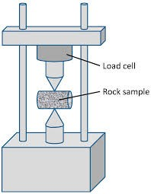

EXPERIMENT NO. 6

Aim: To determine the Protodyakonov strength index of coal.
Scope : This is a very simple test meant to determine the resistance of rock to failure and can be applied to experiments on mass scale. This test is widely used to determine the workability of the coal seams. The test was devised by Protodyakonov, Sr.(1962).
Apparatus Required : Protodyakonov apparatus, coal sample, hammer, sieves, weighing machine.

Procedure
- Prepare five samples from a block of coal. Weigh 50 gm. from each sample which consists of coal pieces of size greater than 19.56 mm (+ ”) and less than 25.4 mm(-1”).
- Put the sample into the cylinder and allow a drop weight (2.4 Kg.) to fall five times from a fixed height of 640 mm.
- Now, remove the crushed coal and keep aside, put next sample into the cylinder and repeat the process for remaining samples.
- When all the samples get crushed in this manner, put the broken coal material of each test on a 0.5 mm (0.02”) sieve and get it seived. Pour the seived fines into the tube of volumometer of 23 mmdiameter.
- Record the height (l) of the coal dust in the volumometer in each case after tapping it lightly 10 times on the table. Calculate the strength coefficient ( Pi).

Calculation :
The strength coefficient (P_{i}) is calculated from the equation :
20 n l
P_{i} =
P_{i} = Strength Coefficient n = no of impacts ofload
l = Height of coal dust involumometer
This strength coefficient is related to the compressive strength by the equation

σ_{c} = sq.rt. (1.06 E P_{i})

where, σ_{c} | = | Compressive strength, Kg f / cm²
E | = | Modulus of elasticity in compression, (take 2 GPa)
P_{i} | = | Strength coefficient.

Observation Table :

S.  N. | Weight of Specimen(gm.) | No. of Impacts (n) | Height in Volumometer (l in mm) | P_{i} =  20 nl
1
2
3
4
5
 |  |  | Average
Result : The Protodykanove Strength Index ofcoalis .
The compressive strength ofcoalis .

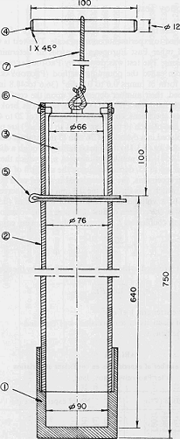
@ cylinder

li+sraTI¥ioofor da<rraiaiograck nrcngtb6y tbegouruttag4cskaiqw

EXPERIMENT NO. 7

Aim: To determine the Impact Strength Index (ISI) of coal sample.
Scope : Evans and Pomeroy (1966) used a procedure similar toProtodyakonov’s one, and they called the measured property “Impact Strength Index, ISI”.
Apparatus Required: Impact strength index apparatus, hammer, coal sample, sieves and weighing machine.

Procedure:
- Take big pieces of coal and break it with hammer. Sieve it by 1” sieve and spread the oversize one on a concrete floor. Break the individual pieces with hammer to give the maximum yield of fragments just under 1” size. Repeat breaking and sieving consecutively until all the pieces of coal passes through 1” mesh sieve. Now, remove 3/8” to 1/8” fraction from broken material by hand sieving. Reject the pieces trapped in thesieve.
- Weigh 100 gm  0.05 gm of sample carefully from the sieved fraction. Take care to avoid further degradation.
- Pour 100 gm of sample gently into the hollow cylinder of the ISI apparatus which is placed on level floor. The base of the apparatus is steadied with the feet and top cap isfitted.
- Raise the plunger to full extent and drop it freely 20 times. The impacting rate is kept faster than once every twoseconds.
- Finally, remove the cap & plunger and sieve the crushed sample through 1/8” sieve. It is sometimes necessary to tap the side of the ISI apparatus slightly to eject thematerial.
- Weigh the sample in grams remaining on 1/8” sieve including the material trapped in sieve is the Impact strength index of coal.

Calculation :
The sum of the weight of specimen remained on 1/8” sieve and material trapped in sieve is divided by the original weight of the specimen. It is represented in %.
% ISI = (W₂ / W₁ ) X 100
where, I.S.I. = Impact Strength Index

W₁ = Weight of specimen ,gm.
W₂ = Weight of specimen remained on 1/8” sieve,gm.
Hobbs (1964) applied this method to rocks and found that the compressive strength is related to ISI, as follows-
σ_{c} = 769 f_{i}–36360
where, σ_{c} = Compressive strength, inPSi
f_{i} = mass of coal in gm. remaining on 1/8”seive

Observation Table :

S.N  . | Weight of  Specimen  (W₁ in gm.) | Weight of remaining specimen on 1/8” sieve (W₂ in gm.) | % ISI = (W₂ / W₁ ) X 100
1 | 100
2 | 100
3 | 100
4 | 100
5 | 100
 |  | Average
Result : The Impact Strength Index ofcoalis . The compressive strength ofcoalis .

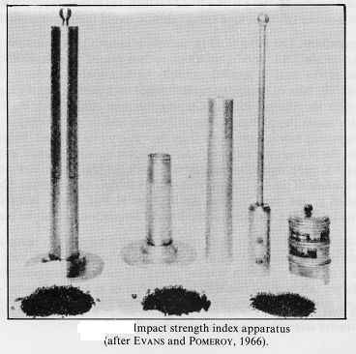

EXPERIMENT NO. 8

Aim: To determine the Schmidt Rebound Hardness Number and compressive strength of a given rock specimen.

Scope :
- This method is suggested to determine the hardness ofrock.
- The method is of limited use on very soft or very hard rock
The Schmidt hammer determines the rebound hardness of a test material. The plunger of the hammer is placed against the specimen and is depressed into the hammer by pushing the hammer against the specimen. Energy is stored in a spring which automatically releases at a prescribed energy level and impacts a mass against the plunger. The height of rebound of the mass is measured on a scale and is taken as the measure of hardness. The device is portable and may be used both in the laboratory andfield.
Apparatus : Schmidt Hammer and Rock Specimen .

Procedure
- Prior to each testing sequence, calibrate the Schmidt hammer by using a calibration test anvil supplied by themanufacturer.
- Record the average of 10 readings on the testanvil.
- Take the representative sample of the rock to be studied. When possible, use larger piecesofrockfortheSchmidthardnesstests.The‘L’typehammershouldbeusedon
NX or larger core specimens or on block specimens having an edge length of at least 6 cm.
- The test surface of all specimens, either in the laboratory or in the field, should be smooth and flat over the area covered by the plunger. This area and the rock material beneath to a depth of 6 cm should be free from cracks, or any localized discontinuity of the rock mass.

- Clamp the small individual pieces of rock, whether tested in the laboratory or in the field, to a rigid base to adequately secure the specimen against vibration and movement during the test. Place the base on a flat surface for providing firmsupport.
- The hardness value obtained may be affected by the orientation of the hammer. It is recommended that the hammer be used in one of three positions vertically upwards, horizontally, or vertically downwards with the axis of the hammer  5º from the desired position. When use of one of the three orientations is not feasible (e.g. in situ testing in a circular tunnel), the test should be conducted at the necessary angle and the results corrected to a horizontal or vertical position using the correction curves supplied by the manufacturer. The hammer orientation for the test and any corrections applied to non- vertical or non-horizontal orientations should be recorded and reported in theresults.
- Take at least 20 readings, conducted on any rock sample. Test locations should be separated by at least the diameter of the plunger. Any test that causes cracking or any other visible failure shall affect that test and the specimen to be rejected. Errors in specimen preparation and testing technique tend to produce low hardnessvalues.

Calculation :
  - The correction factor is calculated as–
Specified standard value of the anvil Correction factor=
Average of 10 readings on the calibration

  - The measured test values for the sample should be ordered in descending value. The lower 50 % of the values should be discarded and average obtained of the upper 50 % values. This average should be multiplied by the correction factor to obtain the Schmidt Rebound Hardness.
  - The compressive strength corresponding to rebound number is noted from the graph given on thehammer.

Observation Table :

S.N  . | Rebound Number | Average of 10 Rebound Number
1

2
3
4
5
6
7
8
9
10
11
12
13
14
15
16
17
18
19
20
Results

- Lithological description of the specimen:
- Source of sample:
- No. of specimen tested :
- Water contained and degree of saturation at the time of test:

- Date of testing and apparatus used:
- Orientation of hammer axis:
- Schmidt Hardness no.:
- Compressive strength:

EXPERIMENT NO. 9

AIM : To determine the Slake Durability Index of Rocks.

Scope :
One good test of durability of rocks is the slake durability test proposed by Franklin andChandra (1972) modified by Gamble and later recommended by ISRM. The apparatus consists of a drum of 140 mm diameter and 100 mm length with sieve mesh (2 mm opening) forming the cylindrical walls. About 500 gm of rock is broken into 10 lumps and loaded inside the drum, which is turned at 20 rpm in a water bath. After ten minutes of this slow rotation, the percentage of rock retained inside the drum (on a dry weight basis) reported as the Slake DurabilityIndex.
This test is intended to assess the resistance offered by a rock sample to weakening and disintegration when subjected to two standard cycles of drying and wetting.

Appatarus :
The apparatus consists essentially of the following :
- A test drum comprising a 2.00 mm standard mesh cylinder of unobstructed length 100 mm and diameter 140 mm with solid fixed base. The drum must withstand a temperature of 105ºc. The drum has a solid removable lid. The drum must be sufficiently strong to retain its shape during use, but neither the exterior of the mesh nor the interior of the drum should be obstructed, for example by reinforcingmembers.
- A trough to contain the test drum supported with axis horizontal in a manner allowing free rotation, capable of being filled with a slaking fluid such as water to a level 20 mm belowthe drum axis. The drum is mounted to allow 40 mm unobstructed clearance between the trough and the base of themesh.
- A motor drive capable of rotating the drum at a speed of 20 rpm. The speed to be held constant to within 5% for a period of 10min.
- An oven capable of maintaining a temperature of 105ºc to within 3ºc for a period of at least 12 hours.
- A balance capable of weighing the drum plus sample to an accuracy of 0.5gm.

Procedure :
- Select a representative sample comprising the rock lumps, each with a mass of 40-60 g , to give a total sample mass of 450-550g. The maximum grain size of the rock is not more than 3 mm. Lumps are roughly spherical in shape and corners are rounded.
- Place the sample in a clean drum and dry to a constant mass at a temperature of 105 ºc, usually requiring from 2 to 6 hr in the oven. Record the mass “A” of the drum plus sample. Test the sample aftercooling.
- Replace the lid, mount the drum in the trough and coupled to themotor.
- Fill the trough with slaking fluid, usually tap water at 20ºc, to a level 20 mm below the drum axis, and rotate the drum for 200 revolutions during a period of 10 min to an accuracy of 0.5 min.
- Remove the drum from the trough and the lid from the drum. Dry the drum plus retained portion of the sample to constant mass at 105ºc. Record the mass “B” of the drum plusretained portion of the sample aftercooling.
- Repeat the steps from (c) - (e) and record the mass “C” of the drum plus retained portion of the sample.
- Brush the drum to clean and record its mass“D”.

Calculation :
The Slake-durability index (second cycle) is calculated as the percentage ratio of final to initial dry sample masses as follows:
Slake-durability index I_{d2} = (( C – D ) / ( A – D )) x 100% Massof‘A’ :
Massof‘B’ :
Massof‘C’ :
Massof‘D’ :
SlakeDurabilityIndex :

Results :

- The Slake-durability index:

- The nature and temperature of the slaking fluid:

- The appearance of fragments retained in the drum:

- The appearance of material passing through the drum:

Note : The second cycle slake durability index, tested with tap water at 20ºc, is proposed for use in rock classification. However, samples with second cycle from 0 to 10% should be further characterized by their first cycle slake durability indexes as follows-
Slake-durability index I_{d1} = (( B – D ) / ( A – D )) x 100 %
Indexes taken after three or more cycles of slaking and drying may be useful when evaluating rocks of higher durability. Rocks giving low slake durability, results should be subjected to soils classification tests, such as determination of Atterberg limits or sedimentation size analysis

EXPERIMENT NO. 10

Aim: To determine the P & S wave velocity and the dynamic properties of a given rock specimen.
Scope : P and S waves are used to gather geotechnical information about a particular area. The nature of the area has been varied, from mountain ranges to plains to sea beds. At the time of measuring the propagation velocity through the core sample by applying the ultrasonic wave transmission method, it is required to note that there exist quite an important relationship between the transducer frequency and the core sample size. The definition is available on ASTM (American Society of Testing Materials) D2845-69, the summary of which is given below:

L = 0.5 ~ 2.5* d, d ≥ 5 * λ
Where L : Length of the core sample (cm)
d : Diameter of the core sample (cm) λ : wavelength (cm)
For example in case of the core sample with its P wave velocity = 5000m/sec, its Diameter = 5 cm and its length 2.5 cm – 12.5 cm the appropriate transducer for the measurement of P wave can be concluded to be the one with its frequency being 500 KHz.
  - P wave velocity (Vp) and S wave velocity(Vs) Vp = 10⁴ * L/Tp
Vs = 10⁴ * L/Ts
Where,
L : Length (cm) of specimen
Tp : Travel time (μ sec) for P wave Ts : Travel time (μ sec) for Swave
  - Dynamic Poisson’s ratio (νd) Dynamic shear modulus (Gd) and Dynamic elastic coefficient(Ed)
νd = {(Vp/Vs)²-2}/2{(Vp/Vs)²-1} Gd = ρ* Vs²(KN/m²)
Ed = 2(1+νd) * Gd

Where, ρ : Density(gm/cm³) of the specimen.
Apparatus Required : Sonic viewer equipment, Rock specimen.

Procedure :
- Measure the length, diameter and density of the core specimen which is required as an input parameter.
- The specimen is sandwiched between the two transducers. For measuring the P wave velocities, the P wave transducers are used and for measuring S wave velocities the S wave transducers areused.
- Measure the ‘P’ and ‘S’ wave velocities separately. Use Vaseline for measuring ‘P’ wave velocity between specimen and transducer. Vaseline is not used in determination of ‘S’ wave velocity.
- The P & S waves are interrelated automatically by giving the command to the equipment. The Dynamic Poisson’s ratio, Dynamic shear modulus and Dynamic elastic coefficient are calculated by the software.

Result :
Dynamic Poisson’s ratio : Dynamic shear modulus :
Dynamic elastic coefficient :

EXPERIMENT

Aim: To determine the cohesive strength and angle of internal friction of given rock specimen by tri-axialtesting.

Scope :
Tri-axial compression test is performed by subjecting a cylindrical rock sample to a lateral confining pressure (σ₃) and loading the specimen axially to failure (σ₁). These stresses are calculated as follows-
σ₃ = Hydraulic pressure
σ₁ = Failure load / cross-sectional area ofspecimen.
In this test also, the rock specimen may fail either by axial (brittle splitting) or in shear by the characteristic cones formed on the shear surfaces (also known as x-shaped fracture or conjugate shear fracture). The specimen may also fail in plane shear. The preparation of specimen is same as for uni-axial compressive strength test but the length to diameter ration should be 2.25 to 2.5. The diameter of specimen should be of NX size (approx. 54 mm).
Mohr Coulomb Failure Criterion : According to this criterion τ = σ_{n} tan + C
Where, τ | = | Shear stress
σ_{n} | = | Normal stress
 | = | Angle of internal friction
C | = | Cohesive strength

Apparatus Used : Tri-axial testing machine, Vernier caliper, rock specimen.

Procedure :
- Mount the specimen in the triaxial cell and place it under a loading frame (MTS) which applies the axial force.

- Apply the lateral pressure (i.e. confining pressure) through hydraulic pump. The axial load is transmitted through triaxial cell in which spherical seats ensure full contact with the specimen parallelends.
- Use a self sealing oil resistant rubber sleeve for transmission of lateral load, so that the rock specimen is closed in an imperviousjacket.
- Dofivetestsatdifferentconfiningpressure.Recordthecorrespondingvaluesofσ₃andσ₁.

Observation Table :

S.  N. | Diameter Of specimen (cm) |  |  |  |  | Cross- sectional Area (sq.cm.) | FailureLoad (Kg) | Confining Pressure (σ_{3,}Kg/cm²) | σ₁  (Kg/ cm²) | Normal Stress  (σ_{n}, Kg/  cm²) | Cohesive Strength  (C, Kg/  cm²) | Angle of Internal Friction ()
 | D  1 | D  2 | D  3 | D  4 | Da  v
1
2
3
4
5
Calculation :
The cohesive strength, angle of internal friction, shear strength and compressive strength at a particular confining pressure may be determined. The following relationships may be used for its calculation-
τ = σ_{n} tan  + C
τ = ((σ₁ - σ_{3,}) / 2) Sin 2α
σ_{n} = ((σ₁ + σ_{3,}) / 2) + ((σ₁ - σ_{3,} ) / 2) Cos 2α)
 = 2α – π / 2
Mohr Circle : It may be determined by plotting the values of σ₁&σ₃on a graph paper as discussedbelow-
- Shear stress (τ) is taken on Y-axis and confining pressure (σ₃) & major principal stress (σ₁) is plotted on X-axis. A circle is drawn taking σ₁&σ₃asdiameter.
- Similar circles are drawn for different specimens on the samegraph.
- A common tangent is drawn to allcircles.

- Inclination of the common tangent from the X-axis and its intercept with Y axis are observed.
These are the angle of internal friction and cohesive strength of the rock respectively.
Result: From the graph, Cohesive strength of the rock = Angle of internal friction =

